USER GUIDE - LOG AN ERROR

August 2018

Version 1.02

Pharmacon ITC303/309 Group

Document Revisions

|  |  |  |
| --- | --- | --- |
| Date | Version Number | Document Changes |
| 26/08/2018 | 1.01 | Initial Draft |
| 26/08/2018 | 1.02 | Draft |
|  |  |  |
|  |  |  |
|  |  |  |
|  |  |  |
|  |  |  |
|  |  |  |
|  |  |  |

Table of Contents

1 Introduction 4

1.1 Scope and Purpose 4

1.2 Process Overview 4

2 Log an Error 6

2.1 Login – General User 6

2.1.1 To Log in to Pharmacy Error Tracker (PET): 6

2.1.2 To Complete the Log Error Form: 6

2.2 Login – Administrator 14

2.2.1 To Log in to Pharmacy Error Tracker (PET): 14

# Introduction

## Scope and Purpose

The purpose of this user guide is to provide instructions for logging an error in the Pharmacy Error Tracker (PET). The user will be taken through the various steps required to successfully log an error. No other features of the PET application will be discussed in this user guide.

* To be able to use PET, the user will need basic knowledge of logging into an online application and completing an online form.
* As a general user, the only available feature is the Log Error form.
* As an administrator, access is available to all the features of PET.
* The process of logging an error is the same for both a general user and an administrator.

## Process Overview

The user will need to log into PET using a valid username and password already assigned to them by an administrator.

* For a general user, the Log Error form will appear on successful login.
* For an administrator, a menu page will be presented on successful login. The administrator will need to select Log Error via the menu bar or the button on the menu page.

The user will need to have all the following details concerning the error:

* Date error occurred
* Time error occurred
* Patient hospital ID
* Patient’s first name and surname
* Patient type (inpatient, outpatient, etc)
* Error type
* Medication given
* Medication type
* Any general comment about error as required
* Worker causing the error
* Whether the worker was notified
* Location of where the error was discovered (e.g., at the dispensary)
* Whether an IIMS was completed
* The severity of the error
* If the physician was notified
  + If notified, Physician provider number, first name, surname and any comment

Login screen when PET is launched

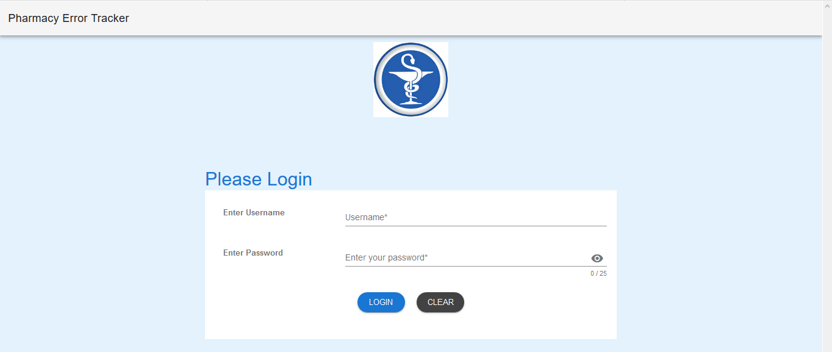

# Log an Error

To log an error, the user will need to launch the application, login with a valid user name and password, and complete the required fields in the form. The form is then submitted to update the database.

## Login – General User

User must have access to the application.

User must have a valid username and password.

### To Log in to Pharmacy Error Tracker (PET):

1. Launch the application.
2. Click in the Username field.
3. Enter username.
4. Tab or click in Password field.
5. Enter password.

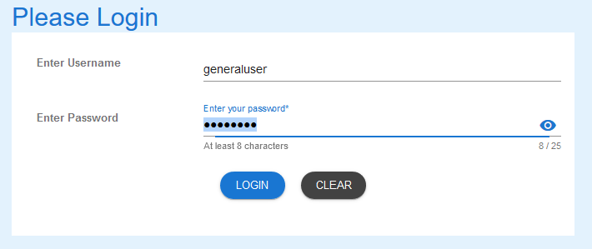

1. Select LOGIN to access PET.

NOTE:

Users entering an invalid username and/or password will not beable to access PET.

Users with administrator rights will need to select Log Error from the Menu Bar or from the list on the Welcome Page – See 2.2 for details

### To Complete the Log Error Form:

1. Enter the date of the error
2. Click in the Date field
3. Select the date the error occurred

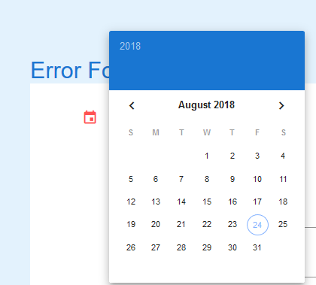

1. Enter the time of the error
   1. Click in the Time field
   2. Select the hour by click and holding on the highlighted “hand” and dragging to appropriate hour and releasing the mouse. You may also click on the appropriate hour.

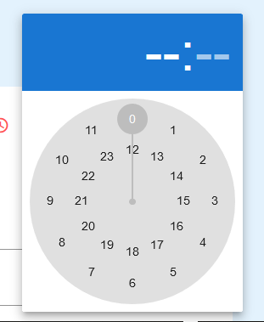

* 1. In the same way, select the appropriate minute (hold and drag method or click on required minute).

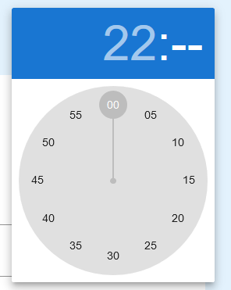

1. Enter details concerning the Patient:
   1. Patient MRN, First Name, and Surname

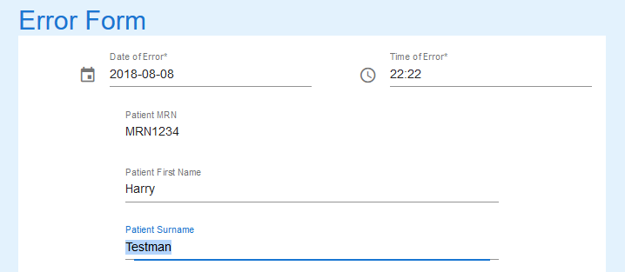

1. Select Patient Type by clicking in the field and selecting from the pop-up list

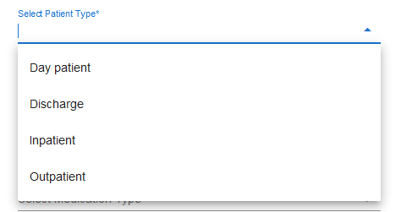

1. Click in Error Type field and select a type from the pop-up list

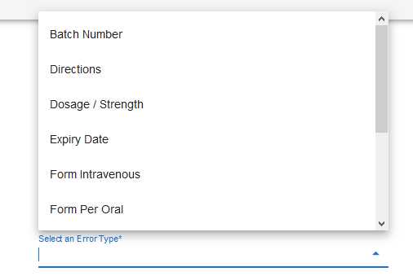

1. Enter the Medication Given in the next field

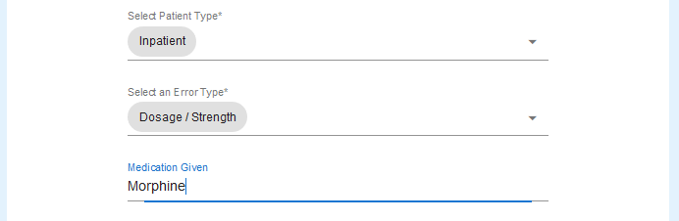

1. Select Medication Type by clicking in the next field and selecting from pop-up list

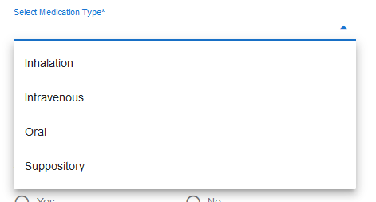

1. Enter an Error Description or General Comment if needed. *Please note, this field can be hidden from view by an Administrator if it is deemed that it is not necessary*.
2. Select the staff member who made the error from the pop-up list

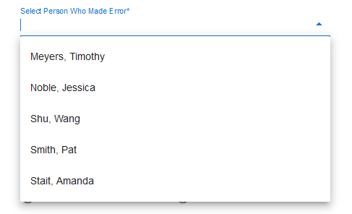

1. Select Yes if the staff member was advised of the error; otherwise select No

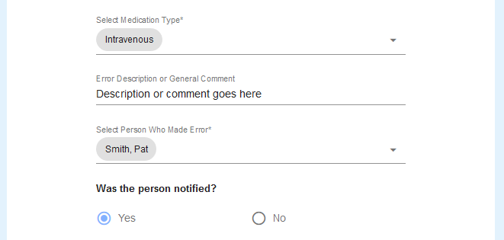

1. Click in the next field and select from the pop-up list where the error occurred

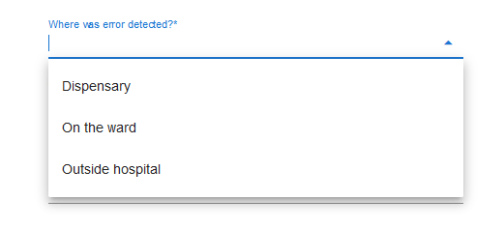

1. Select Yes if an IIMS was completed; No if it wasn’t

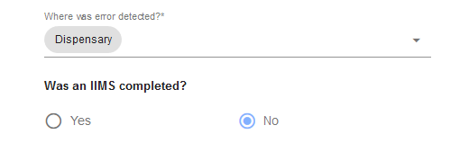

1. Select the severity level of the error by clicking in the next field and selecting from the pop-up list

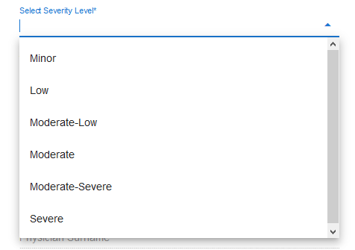

1. The next fields may not appear if the Administrator deems them as not required  
     
   If available, select Yes if Physician was notified; No otherwise.

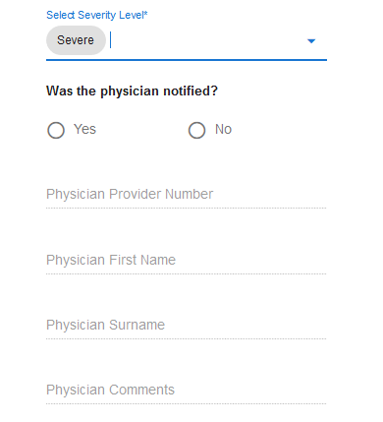

1. If **Yes** selected, enter the following details:
   1. Physician Provider Number
   2. Physician First Name
   3. Physician Surname
   4. Any comment the Physician may wish recorded

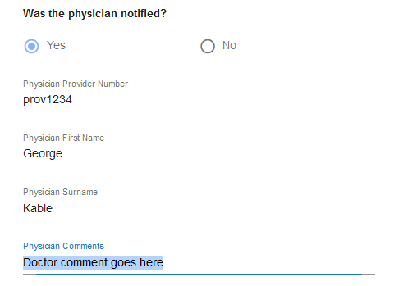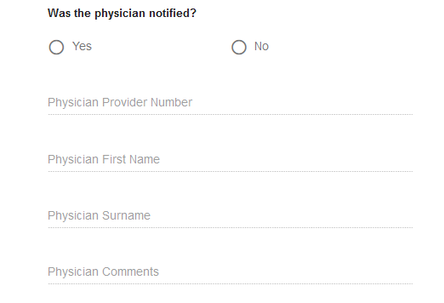

1. If **No** selected, no further details can be entered.
2. Select the Submit button if happy with details entered, Clear if you wish to start clear all fields and start again.



1. If the form is valid, the following message will appear



1. Select Clear to enter the next error.
2. Log out when all errors have been entered.

## Login – Administrator

User must have access to the application.

User must have a valid username and password

### To Log in to Pharmacy Error Tracker (PET):

1. Launch the application.
2. Click in the Username field.
3. Enter username.
4. Tab or click in Password field.
5. Enter password.

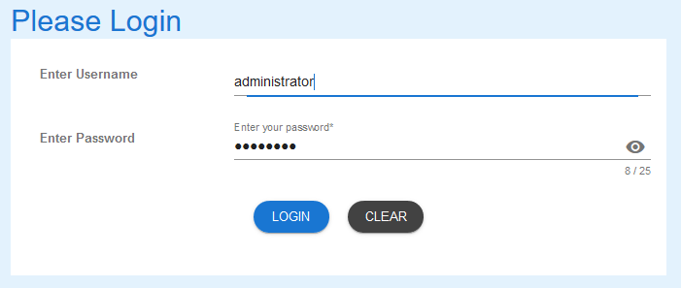

1. As administrator, the following Welcome Page is shown on login.

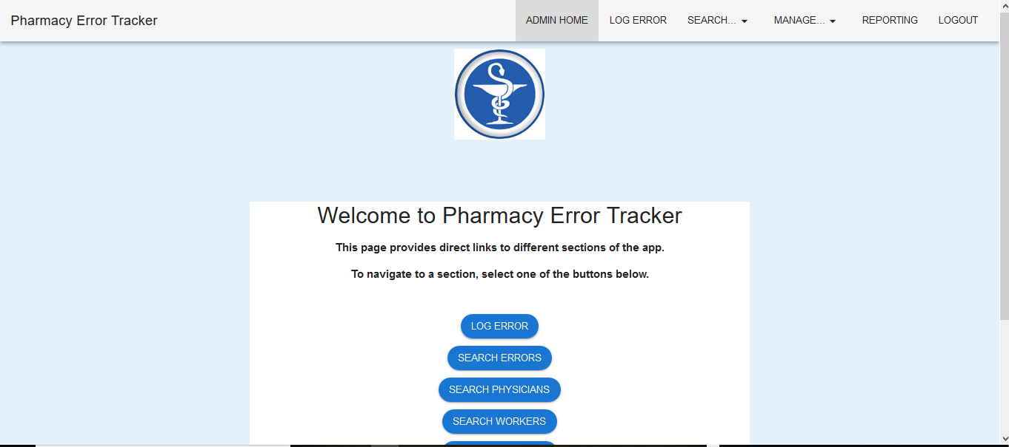

1. To log an error, select either the Log Error button or Log Error from the menu bar. Then follow the instructions as detailed in 2.1.2 (page 6).

If you encounter issues not addressed by this user guide, please contact your account manager for additional support.